LAB 6: PROGRAMMING PIC18F4550 MICROCONTROLLER WITH KEYPAD 4x4
- Objectives:
- Explain the basic operation of a keypad.
- Describe the key press and detection mechanisms
- Learn how to interface keypad with PIC Microcontroller.
- Components
LCD
PIC18F4550
Keypad 4x4
- Introduction to LCD
The keypad is used as an input device to read the key pressed by the user and to process it.
4x4 keypad consists of 4 rows and 4 columns. Switches are placed between the rows and columns. A keypress establishes a connection between the corresponding row and column between which the switch is placed.
In order to read the keypress, we need to configure the rows as outputs and columns as inputs.
Columns are read after applying signals to the rows in order to determine whether or not a key is pressed and if pressed, which key is pressed.
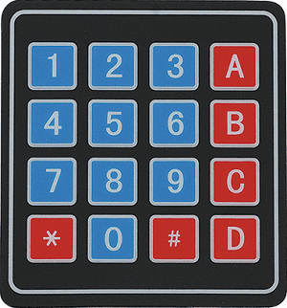
Keypad 4x4

Interfacing Diagram
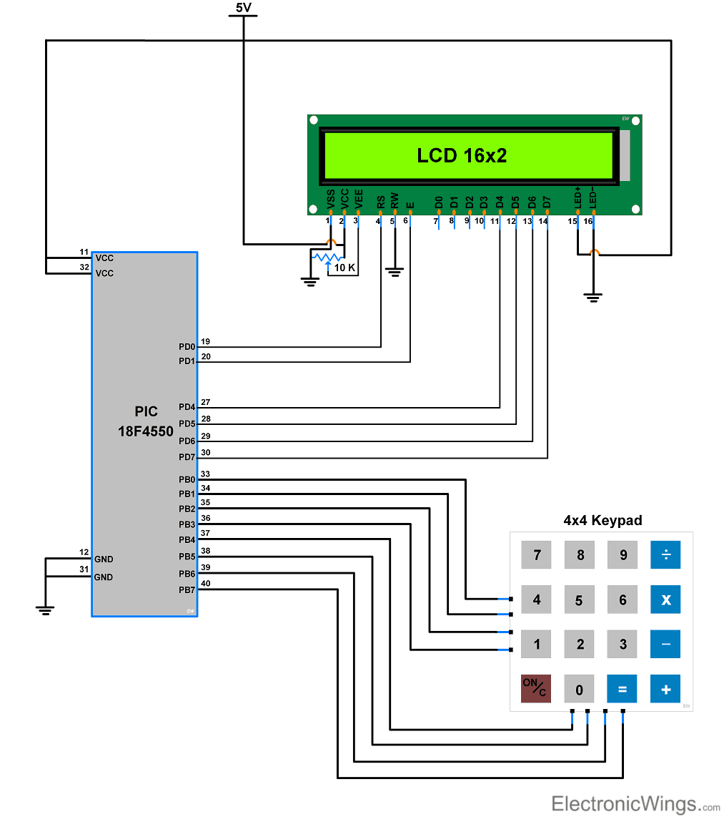

4. Experiment
- Connect the above circuit using Proteus with PIC18F4550
- Write a program to make a calculator with the following features:
- You can give any single digit input from 0 to 9.
- You can press the ‘ON/C’ button at any time to reset the calculator.
- In the PIC calculator project, mathematical operation perform in switch case as per the operators.
- An error message is displayed if the wrong input is detected. For example, if the calculator is expecting a number, but a function key is pressed then the ‘Wrong Input’ message is displayed.
- Similarly, the ‘Wrong Function’ message is displayed if the wrong key is pressed instead of a function key.
- Simulate the circuit using Proteus ISIS program.

Name: Student Code: Class: Lab:
- Circuit
- Algorithm flowchart
- Code and explanation
- Summary

